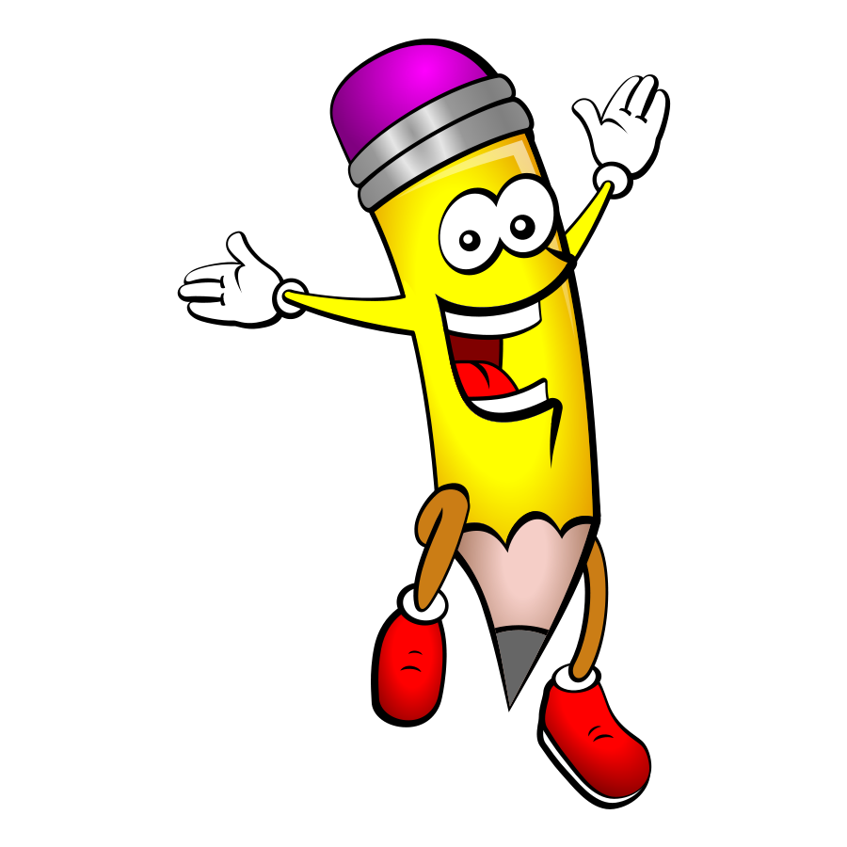Name\_\_\_\_\_\_\_\_\_\_\_\_\_\_\_\_\_\_\_\_\_\_\_\_\_ Date\_\_\_\_\_\_\_\_\_\_\_\_\_

Title\_\_\_\_\_\_\_\_\_\_\_\_\_\_\_\_\_\_\_\_\_\_\_\_\_\_

Author\_\_\_\_\_\_\_\_\_\_\_\_\_\_\_\_\_\_\_\_\_\_\_\_

What does the author help you learn from the text?



Name\_\_\_\_\_\_\_\_\_\_\_\_\_\_\_\_\_\_\_\_\_\_\_\_\_ Date\_\_\_\_\_\_\_\_\_\_\_\_\_

Title\_\_\_\_\_\_\_\_\_\_\_\_\_\_\_\_\_\_\_\_\_\_\_\_\_\_

Author\_\_\_\_\_\_\_\_\_\_\_\_\_\_\_\_\_\_\_\_\_\_\_\_

How is the main character feeling in the story? How do you know?

Name\_\_\_\_\_\_\_\_\_\_\_\_\_\_\_\_\_\_\_\_\_\_\_\_\_ Date\_\_\_\_\_\_\_\_\_\_\_\_\_

Title\_\_\_\_\_\_\_\_\_\_\_\_\_\_\_\_\_\_\_\_\_\_\_\_\_\_

Author\_\_\_\_\_\_\_\_\_\_\_\_\_\_\_\_\_\_\_\_\_\_\_\_

Cut out and fold. Illustrate the beginning, middle and end.

Title Beginning Middle End

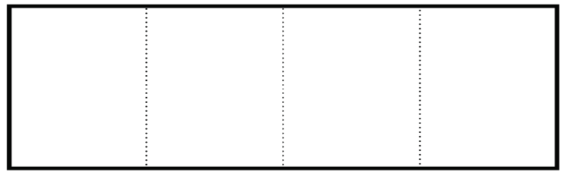



Name\_\_\_\_\_\_\_\_\_\_\_\_\_\_\_\_\_\_\_\_\_\_\_\_\_ Date\_\_\_\_\_\_\_\_\_\_\_\_\_

Title\_\_\_\_\_\_\_\_\_\_\_\_\_\_\_\_\_\_\_\_\_\_\_\_\_\_

Author\_\_\_\_\_\_\_\_\_\_\_\_\_\_\_\_\_\_\_\_\_\_\_\_

Setting

Character

Problem

Solution

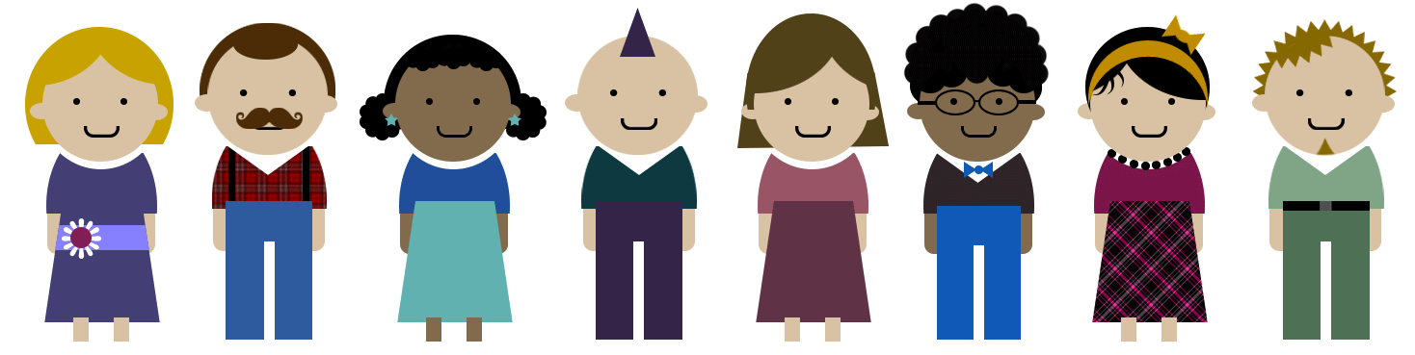

Name\_\_\_\_\_\_\_\_\_\_\_\_\_\_\_\_\_\_\_\_\_\_\_\_\_ Date\_\_\_\_\_\_\_\_\_\_\_\_\_

Title\_\_\_\_\_\_\_\_\_\_\_\_\_\_\_\_\_\_\_\_\_\_\_\_\_\_

Author\_\_\_\_\_\_\_\_\_\_\_\_\_\_\_\_\_\_\_\_\_\_\_\_

Compare and Contrast Characters from 2 stories \

Name\_\_\_\_\_\_\_\_\_\_\_\_\_\_\_\_\_\_\_\_\_\_\_\_\_ Date\_\_\_\_\_\_\_\_\_\_\_\_\_

Title\_\_\_\_\_\_\_\_\_\_\_\_\_\_\_\_\_\_\_\_\_\_\_\_\_\_

Author\_\_\_\_\_\_\_\_\_\_\_\_\_\_\_\_\_\_\_\_\_\_\_\_

    

 DETAILS

Name\_\_\_\_\_\_\_\_\_\_\_\_\_\_\_\_\_\_\_\_\_\_\_\_\_ Date\_\_\_\_\_\_\_\_\_\_\_\_\_

Title\_\_\_\_\_\_\_\_\_\_\_\_\_\_\_\_\_\_\_\_\_\_\_\_\_\_

Author\_\_\_\_\_\_\_\_\_\_\_\_\_\_\_\_\_\_\_\_\_\_\_\_



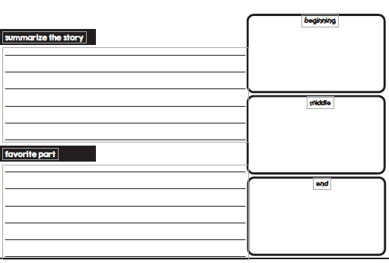

Name\_\_\_\_\_\_\_\_\_\_\_\_\_\_\_\_\_\_\_\_\_\_\_\_\_ Date\_\_\_\_\_\_\_\_\_\_\_\_\_

Title\_\_\_\_\_\_\_\_\_\_\_\_\_\_\_\_\_\_\_\_\_\_\_\_\_\_

Author\_\_\_\_\_\_\_\_\_\_\_\_\_\_\_\_\_\_\_\_\_\_\_\_

Choose words that make you feel happy from the text. \

Illustrate and write the definitions.

  

\_\_\_\_\_\_\_\_\_\_\_\_\_\_\_\_\_\_\_ \_\_\_\_\_\_\_\_\_\_\_\_\_\_\_\_\_\_\_ \_\_\_\_\_\_\_\_\_\_\_\_\_\_\_\_\_\_\_

\_\_\_\_\_\_\_\_\_\_\_\_\_\_\_\_\_\_\_ \_\_\_\_\_\_\_\_\_\_\_\_\_\_\_\_\_\_\_ \_\_\_\_\_\_\_\_\_\_\_\_\_\_\_\_\_\_\_

\_\_\_\_\_\_\_\_\_\_\_\_\_\_\_\_\_\_\_ \_\_\_\_\_\_\_\_\_\_\_\_\_\_\_\_\_\_\_ \_\_\_\_\_\_\_\_\_\_\_\_\_\_\_\_\_\_\_

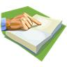Name\_\_\_\_\_\_\_\_\_\_\_\_\_\_\_\_\_\_\_\_\_\_\_\_\_ Date\_\_\_\_\_\_\_\_\_\_\_\_\_

Title\_\_\_\_\_\_\_\_\_\_\_\_\_\_\_\_\_\_\_\_\_\_\_\_\_\_

Author\_\_\_\_\_\_\_\_\_\_\_\_\_\_\_\_\_\_\_\_\_\_\_\_

Describe how the author provides details to support her/his point of view.

Name\_\_\_\_\_\_\_\_\_\_\_\_\_\_\_\_\_\_\_\_\_\_\_\_\_ Date\_\_\_\_\_\_\_\_\_\_\_\_\_

Title 1 \_\_\_\_\_\_\_\_\_\_\_\_\_\_\_\_\_Title 2---------

Author\_\_\_\_\_\_\_\_\_\_\_\_\_\_\_\_\_\_\_\_\_\_\_\_



Text 1

Text 2

Name\_\_\_\_\_\_\_\_\_\_\_\_\_\_\_\_\_\_\_\_\_\_\_\_\_ Date\_\_\_\_\_\_\_\_\_\_\_\_\_

Title\_\_\_\_\_\_\_\_\_\_\_\_\_\_\_\_\_\_\_\_\_\_\_\_\_\_

Author\_\_\_\_\_\_\_\_\_\_\_\_\_\_\_\_\_\_\_\_\_\_\_\_

Draw a picture of what happened at the end of the story and write a summary.



Name\_\_\_\_\_\_\_\_\_\_\_\_\_\_\_\_\_\_\_\_\_\_\_\_\_ Date\_\_\_\_\_\_\_\_\_\_\_\_\_

Title\_\_\_\_\_\_\_\_\_\_\_\_\_\_\_\_\_\_\_\_\_\_\_\_\_\_

Author\_\_\_\_\_\_\_\_\_\_\_\_\_\_\_\_\_\_\_\_\_\_\_\_

Name\_\_\_\_\_\_\_\_\_\_\_\_\_\_\_\_\_\_\_\_\_\_\_\_\_ Date\_\_\_\_\_\_\_\_\_\_\_\_\_

Title\_\_\_\_\_\_\_\_\_\_\_\_\_\_\_\_\_\_\_\_\_\_\_\_\_\_

Author\_\_\_\_\_\_\_\_\_\_\_\_\_\_\_\_\_\_\_\_\_\_\_\_

What is the MAIN IDEA of this text. How do you know? List three details to support your opinion.

The Main Idea is…….

Detail 1

Detail 2

Detail 3

In summary, I

believe the

main

idea is…

Name\_\_\_\_\_\_\_\_\_\_\_\_\_\_\_\_\_\_\_\_\_\_\_\_\_ Date\_\_\_\_\_\_\_\_\_\_\_\_\_

Title\_\_\_\_\_\_\_\_\_\_\_\_\_\_\_\_\_\_\_\_\_\_\_\_\_\_

Author\_\_\_\_\_\_\_\_\_\_\_\_\_\_\_\_\_\_\_\_\_\_\_\_

What was the theme of the story?

Use text evidence to support your opinion.

AN00790_Name\_\_\_\_\_\_\_\_\_\_\_\_\_\_\_\_\_\_\_\_\_\_\_\_\_ Date\_\_\_\_\_\_\_\_\_\_\_\_\_

Title\_\_\_\_\_\_\_\_\_\_\_\_\_\_\_\_\_\_\_\_\_\_\_\_\_\_

Author\_\_\_\_\_\_\_\_\_\_\_\_\_\_\_\_\_\_\_\_\_\_\_\_

Describe how the text made you feel. \

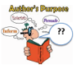Name\_\_\_\_\_\_\_\_\_\_\_\_\_\_\_\_\_\_\_\_\_\_\_\_\_ Date\_\_\_\_\_\_\_\_\_\_\_\_\_

Title\_\_\_\_\_\_\_\_\_\_\_\_\_\_\_\_\_\_\_\_\_\_\_\_\_\_

Author\_\_\_\_\_\_\_\_\_\_\_\_\_\_\_\_\_\_\_\_\_\_\_\_

Why did the author write the text?

Name\_\_\_\_\_\_\_\_\_\_\_\_\_\_\_\_\_\_\_\_\_\_\_\_\_ Date\_\_\_\_\_\_\_\_\_\_\_\_\_

Title\_\_\_\_\_\_\_\_\_\_\_\_\_\_\_\_\_\_\_\_\_\_\_\_\_\_

Author\_\_\_\_\_\_\_\_\_\_\_\_\_\_\_\_\_\_\_\_\_\_\_\_

\_\_\_\_\_\_\_\_\_\_\_\_\_\_\_\_\_\_\_\_\_\_\_\_\_ has several characteristics.

One characteristic is \_\_\_\_\_\_\_\_\_\_\_\_\_\_\_\_. Another is \_\_\_\_\_\_\_\_\_\_\_,

which is important because \_\_\_\_\_\_\_\_\_\_\_.

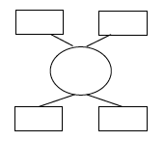

Name\_\_\_\_\_\_\_\_\_\_\_\_\_\_\_\_\_\_\_\_\_\_\_\_\_ Date\_\_\_\_\_\_\_\_\_\_\_\_\_

Title\_\_\_\_\_\_\_\_\_\_\_\_\_\_\_\_\_\_\_\_\_\_\_\_\_\_

Author\_\_\_\_\_\_\_\_\_\_\_\_\_\_\_\_\_\_\_\_\_\_\_

Re-read the text. What events or steps are included?

**Here is how a \_\_\_\_\_\_\_\_\_\_\_\_\_\_\_\_\_\_\_\_\_\_\_\_\_\_\_\_\_\_\_\_\_\_\_\_\_\_\_\_\_\_\_\_is made.**

**First, \_\_\_\_\_\_\_\_\_\_\_\_\_\_\_\_\_\_\_\_\_\_\_\_\_\_\_\_\_\_\_\_\_\_\_\_\_\_\_\_\_\_\_\_\_\_\_\_\_\_\_\_\_\_\_\_\_\_.**

**Next, \_\_\_\_\_\_\_\_\_\_\_\_\_\_\_\_\_\_\_\_\_\_\_\_\_\_\_\_\_\_\_\_\_\_\_\_\_\_\_\_\_\_\_\_\_\_\_\_\_\_\_\_\_\_\_\_\_\_.**

**Then, \_\_\_\_\_\_\_\_\_\_\_\_\_\_\_\_\_\_\_\_\_\_\_\_\_\_\_\_\_\_\_\_\_\_\_\_\_\_\_\_\_\_\_\_\_\_\_\_\_\_\_\_\_\_\_\_\_\_.**

**Finally, \_\_\_\_\_\_\_\_\_\_\_\_\_\_\_\_\_\_\_\_\_\_\_\_\_\_\_\_\_\_\_\_\_\_\_\_\_\_\_\_\_\_\_\_\_\_\_\_\_\_\_\_\_\_\_\_.**

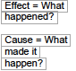Name\_\_\_\_\_\_\_\_\_\_\_\_\_\_\_\_\_\_\_\_\_\_\_\_\_ Date\_\_\_\_\_\_\_\_\_\_\_\_\_

Title\_\_\_\_\_\_\_\_\_\_\_\_\_\_\_\_\_\_\_\_\_\_\_\_\_\_

Author\_\_\_\_\_\_\_\_\_\_\_\_\_\_\_\_\_\_\_\_\_\_\_\_

Use the sentence frames to explain why or how something happened.

The reason why \_\_\_\_\_\_\_\_ happened was because of \_\_\_\_\_\_\_\_\_\_. If \_\_\_\_\_\_\_\_ hadn’t happened, then \_\_\_\_\_\_\_\_\_. Due to \_\_\_\_\_\_\_\_\_ occurring, \_\_\_\_\_\_. This explains why \_\_\_\_\_\_\_.

Name\_\_\_\_\_\_\_\_\_\_\_\_\_\_\_\_\_\_\_\_\_\_\_\_\_ Date\_\_\_\_\_\_\_\_\_\_\_\_\_

Title\_\_\_\_\_\_\_\_\_\_\_\_\_\_\_\_\_\_\_\_\_\_\_\_\_\_

Author\_\_\_\_\_\_\_\_\_\_\_\_\_\_\_\_\_\_\_\_\_\_\_\_